**AIMS+ User Manual   
(Reports, Exporting and Printing)**

## Install and open the Google Chrome browser

## To generate result cards, select a result card report criteria as per previous practice

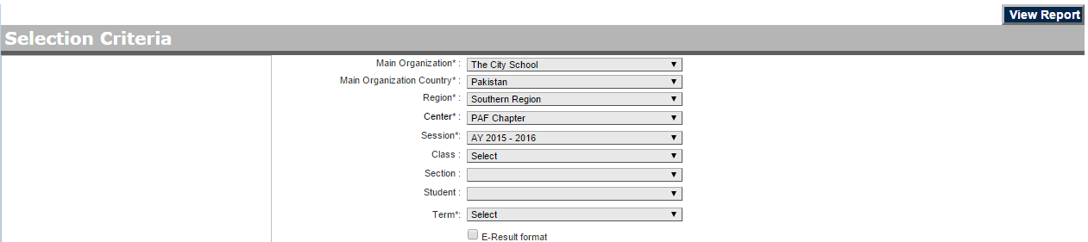

## The report card will display on a webpage

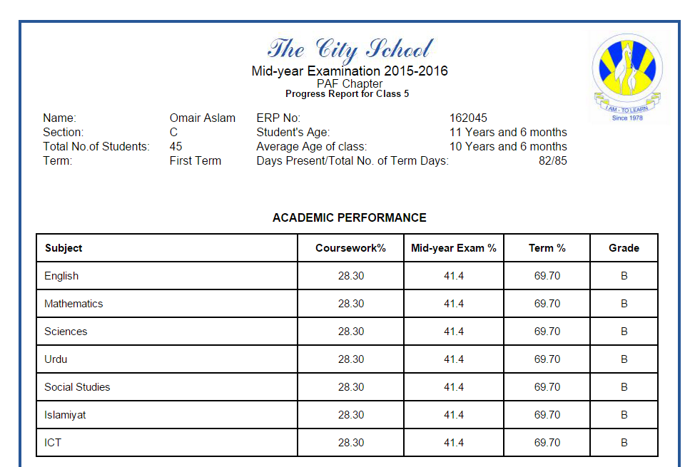

# **1-Direct Printing from Browser:**

## Before printing, configure following printer settings on Google Chrome browser

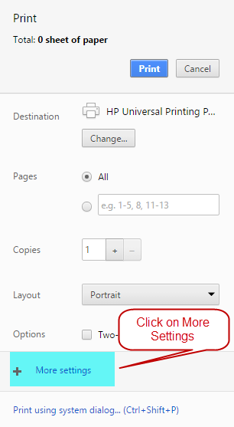

## Collapse More Settings:

1. **Paper Size:** A4
2. **Margins:** Default
3. **Options:** Uncheck Headers and Footers

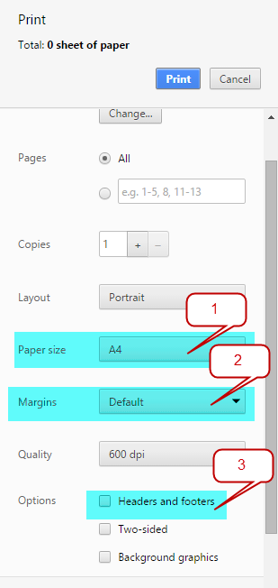

# **2-Export as PDF:**

## Click on **“Change”** Button as shown in below figure:

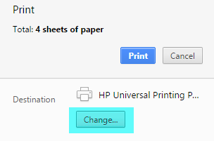

## A dialogue box will appear as shown in the following figure, select “**Save as PDF**” option.

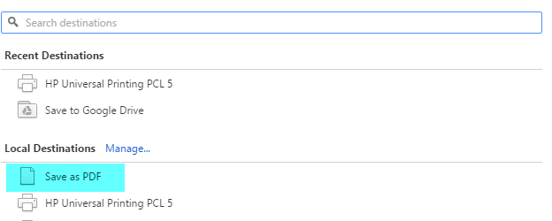

## Configure Print settings:

1. **Paper Size:** A4
2. **Margins:** Default
3. **Options:** Uncheck Headers and Footers

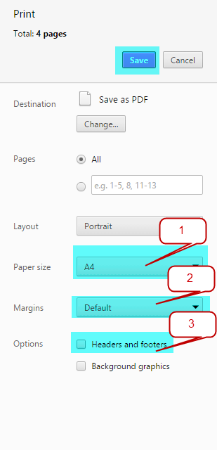

## Click on “**Save**” button to store result cards on your computer.

